Warning - Check 4x4 / Check AWD with Fixed PM Telltale – CGEA 1.3

Functional Description

The purpose of the Check 4x4 / Check AWD Warning is to inform the driver of a malfunction in the vehicles 4x4 or AWD (All Wheel Drive) systems. This module is to be implemented when a fixed LED is used for the Powertrain Malfunction (wrench) telltale.

The Check 4x4 / Check AWD Warning correlates the AwdSrvcRqd_B_Rq signal originating from the TCCM, and the Operational _Mode to determine when to display the Check 4x4 or Check AWD Warning.

This SPSS section must be used when a fixed LED is used for the Powertrain Malfunction (wrench) telltale. For applications with Powertrain Malfunction RTT, use the Powertrain Malfunction RTT with Check4x4_AWD Message STSS for both RTT and warning messages.

4x4_CAN_HW_Cfg is only required/implemented on those programs equipped with the MSOS 4x4 system. The only program known to have the MSOS 4x4 system (as of 10Jan2015) is P558.

Interfaces

Interface Context Diagram (I/O Block Diagram)
Figure 1 Check 4x4 / Check AWD Warning Context Diagram

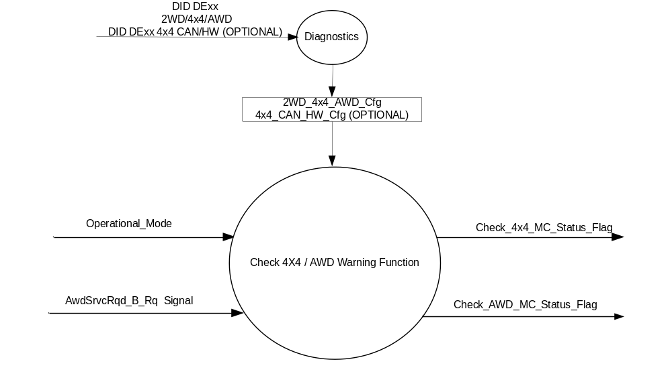

Inputs
      - INTERNAL:
    - Operational_Mode
    - 2WD_4x4_AWD_Cfg
    - 4x4_CAN_HW_Cfg (OPTIONAL)

- MUX message on the CAN Bus

- AwdSrvcRqd_B_Rq Signal
Signal Name | Size  (bits) | Pos.  (bit) | Detail | Units | Res. | Offset | State Encoded | Min. | Max.
AwdSrvcRqd_B_Rq | 1 | 47 |  | SED | 1 | 0 |  | 0  (0x0) | 1 (0x1)
 |  |  | Off |  |  |  | 0x0
 |  |  | On |  |  |  | 0x1

Output
- Check_4x4_MC_Status_Flag which is used to control the state of the Check 4x4 Message.
- Check_AWD_MC_Status_Flag, which is used to control the state of the Check AWD Message.

Function/Performance

Operational Modes

Mode | Differentiating Vehicle Conditions
Sleep Mode | OFF
Limited Mode | OFF
Normal Mode | Check_4x4_MC_Status_Flag, Check_AWD_MC_Status_Flag ON / OFF
Crank Mode | Check_4x4_MC_Status_Flag, Check_AWD_MC_Status_Flag ON / OFF

The above table references the setting of the Warning flag as per this section. However, the actual warning display operational modes are displayed in the Message Center section of this SPSS.

Voltage Levels

Refer to the Cluster Features Table located in the Operational Modes and Voltage Range Strategies Section of this SPSS.

Human-Machine Interface

Visual

Indicator Graphics / Display Format
Message Center Text Warning Message as defined in section 1.3.5.7 of this document.

1.3.3.1.2 Indicator Color Coordinates

Reference section COLOR & ILLUMINATION REQUIREMENTS (GRAPHICS).

Audio

None

Switch Control Logic

None.

System Accuracy

Within 100 msec of receiving a message that results in a change of state the cluster will update the output flag to the proper state.

Operation: Performance and Functional

Subsystem Algorithm Flowchart / State Diagram

Figure 2 Check 4x4 / Check AWD Warning Configuration Flow Chart

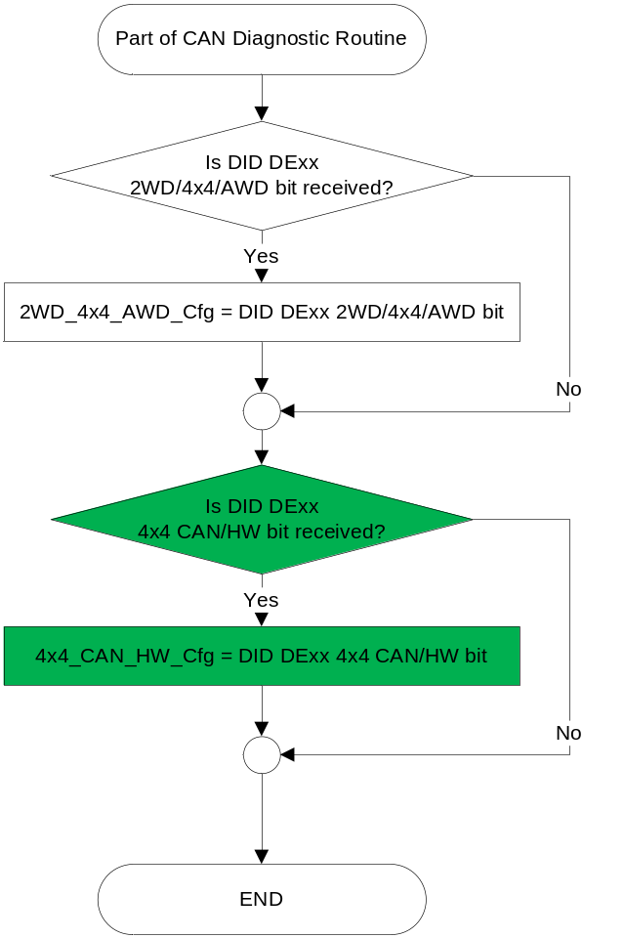

- State Matrix for Check 4x4 / Check AWD Warning
Operational  _Mode | 2WD/4x4/AWD  _Config | 4x4_CAN_HW_Cfg | AwdSrvcRqd_B_Rq Signal | Check_4x4_MC  _Status_Flag | Check_AWD_MC  _Status_Flag
Normal or Crank | 4x4 (0x1) | CAN (0x1) | On (0x1)  Or ( missing per section 1.4.1) | Active | Inactive
Normal or Crank | AWD (0x2) | CAN (0x1) | On (0x1)  Or ( missing per section 1.4.1) | Inactive | Active
All Other Cases |  |  |  | Inactiive | Inactive
4x4_CAN_HW_Cfg is only required/implemented on those programs equipped with the MSOS 4x4 system. The only program known to have the MSOS 4x4 system (as of 10Jan2015) is P558.

- MC Status Flag to Warning ID
MC_Status_Flag | Mc Warning - Message ID
Check_4x4_MC_Status_Flag | W725
Check_AWD_MC_Status_Flag | W726

Operation Description (supports algorithm flowchart /state diagram)
- For definition of how the Message Center arbitrates and displays Active warnings, see the Warning / Alert Display Logic Diagram, located in the Message Center – X Display with W Button Interface section of this SPSS (where X and W are appropriate values in this document).

Function Safety Classification (EMC)

Class B

Memory Storage
Parameter Name | Description | Value at  Battery Connect | Value at  Module Wake-up
AwdSrvcRqd_B_Rq Signal | CAN Signal sent from the TCCM | Off (0x0) | Off (0x0)
Check_4x4_MC_Status_Flag | State variable used by M/C Warning Arbitrator | INACTIVE | INACTIVE
Check_4x4_MC_Status_Flag | State variable used by M/C Warning Arbitrator | INACTIVE | INACTIVE
2WD_4x4_AWD_Cfg | State indicator for feature presence controlled via CAN at EOL at VO plant. | Use Stored Value | Use Stored Value
4x4_CAN_HW_Cfg *  (OPTIONAL) | Encoded indicator of feature presence controlled via CAN at EOL at VO plant. | Use Stored Value | Use Stored Value
Operational_Mode | 4 state indicator for cluster operational mode | Limited | Limited or Normal or Crank

Prove Out

No.

Reconfigurable Telltale

No.

Message Center Msg

Message ID W725 and W726 as defined in the Text Message List section of this SPSS.

Error Handling

Missing Message Strategy

The signals will be declared missing as per the Diagnostics section of this SPSS.

Diagnostics

Self Test

None

Engineering Test Mode

Not Applicable

Part II Performance

Supported Diagnostic Trouble Codes (DTCs)
DTC | Description | Configuratin
C10200 | Lost Communication with Transfer Case Control Module | (2WD_4x4_AWD_Cfg = 4X4 (0x1)  or = AWD (0x2)) and 4x4_CAN_HW_Cfg = CAN⁽¹⁾
- Implement only for vehicle lines equipped with MSOS 4x4 System to prevent logging incorrect DTC .

DID DExx
Block  Num | Block Description | Size (bits) |  | Byte(s) | Bits | State: Description | "0" | "1" | Default | Comments/  Information
PACKETED BLOCKS
xx | Option Content (B&A) |  |  | * | 2 | 2WD/4x4/AWD | encoded | encoded | 01 - 4x4
 |  |  |  |  |  | 00 - 2WD | encoded | encoded
 |  |  |  |  |  | 01 - 4x4 | encoded | encoded
 |  |  |  |  |  | 10 - AWD | encoded | encoded
 |  |  |  |  |  | 11 – Not Used | encoded | encoded
 |  |  |  | * | 1 | 4x4 CAN/HW | HW | CAN | CAN | Optional
*Byte and bit location to be identified in Part II Specification for this cluster

Reference Specification

IS-0001 WARNINGS/INDICATORS/DISPLAYS PROVEOUT
IS-0052 OPERATING VOLTAGES - FUNCTIONAL/PERFORMANCE
IS-0069 FUNCTIONAL IMPORTANCE CLASS
IS-0324 WINDSHIELD & OTHER REFLECTIONS
IS-0327 WARNING INDICATOR EVALUATION
IS-0379 NORTH AMERICAN WARNINGS AND INDICATORS STRATEGY

IL-0017 TELLTALE AND INTERIOR ILLUMINATION – COLOR AND INTENSITY
IL-0019 GENERAL ILLUMINATION DIMMING
IL-0021 CRAFTSMANSHIP – DISPLAYS
IL-0022 GENERAL ILLUMINTATION COLOR
IL-0023 CLARITY/LEGIBILITY/READABILITY/VISUAL CONTRAST
IL -0043 OPERATIONAL ENVIRONMENT FUNCTIONALITY
IL -0045 COLOR
IL -0047 TELLTALE, INDICATOR AND DISPLAY LIGHT INTENSITY
IL -0048 ILLUMINATION ACCEPTABILITY

03-0661 PLACEMENT: CONTROL AND DISPLAY LOCATIONS
03-0662 PLACEMENT: LOGICAL GROUPING FUNCTION AND USAGE
03-0664 PLACEMENT: DOWN VISION TO COMPONENTS WITH HIGH VISUAL DEMAND
03-0665 PLACEMENT: EXPECTED LOCATIONS OF CONTROLS AND DISPLAYS VDS
03-0670 INTERIOR VISIBILITY
03-0671 INTERIOR VISIBILITY: REFLECTIONS FROM COMPONENTS & SURFACES
03-0672 INTERIOR VISIBILITY: REFLECTIONS IN DISPLAYS
03-0673 INTERIOR VISIBILITY: VISUAL OBSCURATIONS
03-0674 INTERIOR VISIBILITY: ILLUMINATION CONTROLS / DISPLAYS
03-0675 INTERIOR VISIBILITY: VEILING GLARE
03-0677 INTERIOR VISIBILITY: SUNLIGHT WASHOUT
03-0681 IDENTIFICATION: CHARACTER AND SYMBOL SIZE
03-0682 IDENTIFICATION: LEGIBILITY
03-0685 IDENTIFICATION: SYMBOLS, ABBREV FOR CONTROL
03-0721 LOGIC OF OPERATION: OPERATIONAL STEREOTYPES
03-0722 LOGIC OF OPERATION: INTERPRETATION
03-0723 LOGIC OF OPERATION: USE OF SYSTEMS WITH VISUAL DISPLAYS

Revision History
SPSS Module Revision History

Revision Level | Name | Change Description | Date
1.0 | J.Blatchford | INITIAL RELEASE | 4/2/2013
1.1 | S. Watkins  M. Hakim | Section 1.5.3  Added configuration condition for logging the DTC. | 8/14/2013
1.2 | S. Watkins | Found inconsistency with other STSS. Changed section 1.3.5.4, for CAN signal AwdSrvcRqd_B_Rq , value at module wakeup to 0x0 (Off). | 9/4/2013
2.0 | J. Blatchford | This change adds 4x4 CAN/HW configuration to prevent the warning from displaying on MSOS equipped vehicles which do not have a TCCM. Except for Figure 1 changes highlighted in green:  - 1.1: Added note.  - Figure 1: Added 4x4_CAN_HW_Cfg  - 1.2.2: Added config input.  - Table 1.1: Added config. Added note below table.  - 1.3.5.4: Added config.  - 1.5.3: Added condition to DTC logging. Added config to DExx configuration table. | 1/12/15

